

**To:** City Executive Board

**Date:** 12th March 2013

**Report of:** Head of Policy, Communication and Culture

**Title of Report:** OXFORD CITY COUNCIL, CHILDREN AND YOUNG PEOPLE’S PLAN 2014-17

# Summary and Recommendations

**Purpose of report**: To seek approval from the City Executive Board on the proposed Oxford City Council, Children and Young People’s Plan 2014-17.

# Key decision: No

**Executive lead member:** Cllr Steve Curran, Executive Board Member, Youth and Communities

**Report approved by:**

Finance: Emma Burson, Business Partners

Legal: Emma Griffiths, Supervising Lawyer

**Policy Framework:** The Corporate Plan and the Oxford Strategic Partnership Plan.

**Recommendation(s):**

To approve the ‘Oxford City Council, Children and Young People’s Plan 2014-17’, subject to any specified amendments.

Appendices 1: Oxford City Council's Draft Children and Young People’s Plan 2014-2017 Summary of consultation response

Appendices 2: Risk Assessment

Appendices 3: Equality Impact Assessment Screening

Appendices 4: Proposed Oxford City Council Children and Young People’s Plan

2013-17

**The purpose of the City Council Children and Young People’s Plan**

1. The Children and Young People’s Plan sets out the identified needs of children and young people in the city. In particular it sets out changes in the population and the economy, information on poverty, attainment and health and wellbeing and the challenges that this brings.
2. The Plan sets out the vision and key objectives for children and young people in the city and the way in which Oxford City Council services will contribute to meeting these challenges over a three year period.
3. The Plan aims to provide a single overarching plan for Oxford City Council services for children, young people and their families in order to help both the Council and its partners coordinate and integrate the work that they do, and to improve the lives of children and young people. It draws on a number of Oxford City Council service plans, including housing, Leisure, parks and Communities and community safety.
4. The Plan sets out links to the strategies and plans of other agencies and partners, such as Oxfordshire County Council, Thames Valley Police, and the Oxford Clinical Commissioning Group.
5. The Plan builds on the established ‘Every Child Matters’ aims: for every child to have the support that they need to be healthy; stay safe; enjoy and achieve; make a positive contribution and to achieve economic wellbeing. It supports the recently revised ‘Working Together to Safeguard Children’ which sets out how organisations and individuals should work together to safeguard and promote the welfare of children.

**The development of the Children and Young People’s Plan 2014-17**

1. The Draft Children and Young People’s Plan 2014-17 builds on the previous ‘Oxford City Council Children and Young People’s Plan 2010-13’.
2. The Plan is underpinned by the Oxfordshire Joint Needs Assessment and a detailed Needs Analysis commissioned by Oxford City Council to better understand the needs of children and young people living in Oxford.
3. There have been two workshops held with Oxford City Council staff from all the service areas that are engaged with children, young people and families. The Draft Plan has been circulated to all Service Heads and other key officers and members for comment.
4. The Plan has been informed by consultation undertaken on the Youth Ambition Strategy.
5. The Plan has also been circulated for initial comment to key partners in Oxfordshire County Council, Oxford Clinical Commissioning Group, Job Centre Plus and Thames Valley Police.

**The Vision for Children and Young People**

1. In Oxford City Council the vision for Children and Young People in the City is that:

‘We intend Oxford to be a world class city for children and young people to live in, by ensuring children and young people have the opportunities to develop the skills and confidence they need to fulfil their potential.’

The priorities for children and young people in the city

1. The City Council has identified the following 5 key priorities.

* Improve the health and wellbeing of children and young people.
* Reduce the social, education and economic inequalities for children and young people.
* Keep children and young people safe.
* Develop the skills, confidence and achievement of children and young people.
* To empower young people in decision making and provide a ‘youth voice’ in how services are delivered.

1. With each priority the Plan sets out the following information:

* What are the needs?
* What we currently do as a City Council
* Actions to focus on over the next 12 months.

**The key elements of the Plan**

1. The Plan includes the following sections:

* The Oxford City Context
* The Vision and Underlying Principles
* The Priorities
* How we will work together to deliver these priorities

Annex 1: Action Plan

Annex 2: Monitoring –How do we know we are making a difference?

Annex 3: Related Plans and Strategies

**Managing and monitoring the Plan**

1. The individual elements of the Oxford City Council Children and Young People’s Plan will be managed by the relevant service area within the Council. Overall coordination of the Plan will be undertaken by the Oxford City Council Partnership Development Manager.
2. The key actions within the Oxford City Council Children and Young People’s Plan will also be overseen by the Stronger Communities Programme Board.
3. It is proposed that the Plan is reviewed on an annual basis, along-side a proposed annual review of safeguarding children and that this is reported to CEB and Council.

**The public consultation process**

1. Details of the proposed public consultation process are set out in Appendices 1. The consultation ran from 7th January 2013 to 9th February 2014 on E Consult. There has also been consultation with Children and Young People through ……
2. A summary of consultation responses and how the comments made have been addressed is also set out in Appendix 1.

**Financial implications**

1. There are no immediate financial implications related to the proposals set out in the Children’s Plan 2014-17. All services set out are currently provided within existing City Council budgets.
2. There are no immediate financial implications related to the proposed Action Plan. These will be resourced from within existing budgets. The exception is a budget proposal for an additional 0.5 FTE post to support work around safeguarding children and vulnerable adults (see the Safeguarding Children Review Report elsewhere on this agenda).
3. Oxfordshire County Council is currently consulting on making substantial reductions to budgets which may impact upon children’s services in the city. In particular there are some proposals to review Children’s Centres and Early Intervention Hubs, although no decisions have yet have been taken.
4. If there is substantial change it may be necessary to revise the focus of services that the City Council is providing and to work even closer with other partners to reduce the impact of these service reductions. It is unlikely that that the implications will be fully understood until March or April 2014.

**Legal Implications**

1. There is no legal obligation for the City Council to have a Children and Young People’s Plan. However, the City Council can be held to account as to how it contributes to the delivery of the Joint Health and Wellbeing Strategy priorities and objectives, including those relating to children and young people.
2. Since the Council does not have direct responsibility for all of the services it is seeking to influence in connection with children and young people, it has to utilise the power contained in section 2 of the Local Government Act 2000, the “well-being power” to do so. The power enables the Council to do anything which it considers likely to achieve the promotion or improvement of the economic, social or environmental well-being of its area. The section provides the legal framework that the Council can utilise to improve the quality of life, opportunity and health of local communities. In using the power the Council must have regard to its sustainable community strategy. The Children and Young People’s Plan will directly affect the well-being of the children and young people within the City.”

**Risks**

1. A risk assessment is provided in Appendices 2,
2. A major risk within the Children and Young People’s Plan is to ensure that the services provided by the City Council and other agencies meet the needs of the children and young people in the city. To mitigate this risk an evidenced based approach has been adopted using data and performance monitoring information which highlight the specific needs of children and young people within the city.
3. Another major risk is the need for the County Council to make significant budget reductions which may lead to cuts in services for children and young people. To mitigate this risk the City Council will need to work with partners to ensure that best use of resources is made and to limit the impact on children and young people where possible. The City Council will need to ensure that it is well informed of potential service cuts and that it uses its leadership role to influence decisions of partners and other agencies.
4. The impact of the budget reductions are unlikely to be known until March or April 2014. As a result the focus for actions, set out in the Plan, are only for 12 months, providing an opportunity to review the position for 2015-17.

**Climate Change/environmental impact**

1. There is no significant climate-change or environmental impact issues related to this report.

# Equalities Impact Screening

1. An Equalities Impact Screening has been carried out and this is set out in Appendices 3. The evidence indicates that there are significant inequalities within the City in comparison to other parts of Oxfordshire. The Plan aims to address the following issues:

* Poor education attainment, in particular for some ethnic minority groups.
* Poor health and health inequalities.
* Child poverty, the rate of which is higher than the national average
* Severe housing shortage leading to homelessness and overcrowding and poor quality housing.
* Children and young people at risk of abuse and child sexual exploitation.

1. There are a number of actions in the Plan which aims to address these issues. There are no groups which will be disadvantaged by the proposals set out in the Plan.

|  |
| --- |
| **Name and contact details of author:-** |
| Name: Val Johnson |
| Job title: Policy and Partnerships Manager |
| Service Area / Department: Policy, Communication and Culture |
| Tel: 01865 252209 e-mail: vjohnson@oxford.go.uk |

**Version number: 3**

**Annex 1**

Oxford City Council's Draft Children and Young People’s Plan 2014-2017

**Summary of consultation response**

**INTRODUCTION**

The public consultation on Oxford City Council’s draft Children and Young People’s Plan opened on 8 January 2014 and closed on 9 February 2014.

The draft plan, accompanying needs analysis and consultation questionnaire were published on Oxford City Council’s e-consult system and publicised on the City Council website. All members stakeholder groups and partners were send direct emails with the link to the consultation.

The online consultation received a total of 35 responses including 28 from individuals and 7 on behalf of organisations. Other comments and suggestions for improvements to the plan were made on email and have been considered separately (not included in these overall findings).

**CONSULTATION RESPONSE**

Overall, the vast majority of respondents agreed with the vision, priorities, actions and principles as set out in the draft Oxford City Council Children and Young People’s plan.

33 out of the 35 respondents (94%) agreed or strongly agreed with the vision for the Children and Young People’s plan.

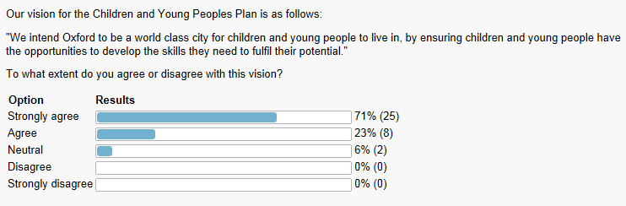

Over 90% of respondents supported the key priorities of the plan with the exception of “increase the influence and power of young people in the shaping and delivering of services” where 9 respondents were neutral and 2 disagreed.

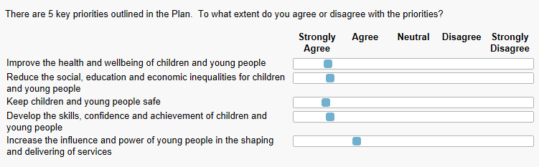

There was strong support for the actions set out in the plan. The area of most disagreement was “increase the influence and power of young people…” where there were concerns about cost, fully representing all types of young people and how to best engage young people.

83% agreed or strongly agreed with proposed actions to improve the health and wellbeing of children and young people.

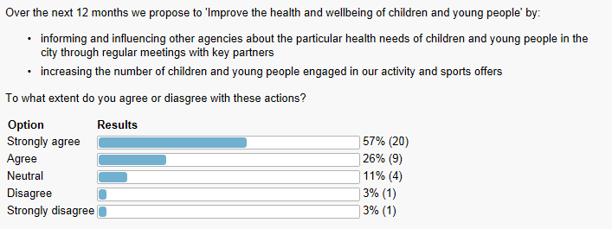

86% agreed or strongly agreed with proposed actions to reduce the social, education and economic inequalities of children and young people.

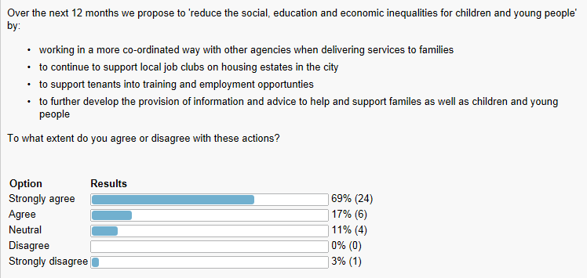

92% agreed or strongly agreed with proposed actions to keep children and young people safe.

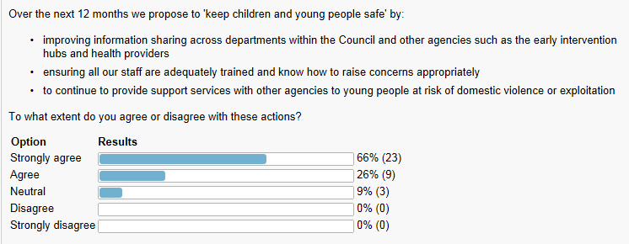

89% agreed or strongly agreed with proposed actions to develop the skills, confidence and achievement of children and young people.

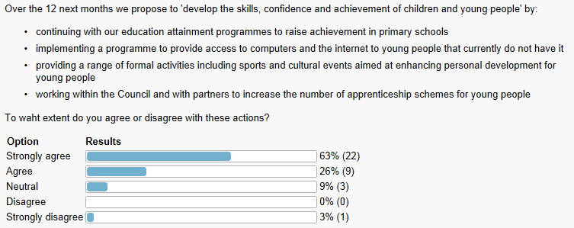

73% agreed or strongly agreed with proposed actions to increase the influence and power of young people in the shaping and delivering of services.

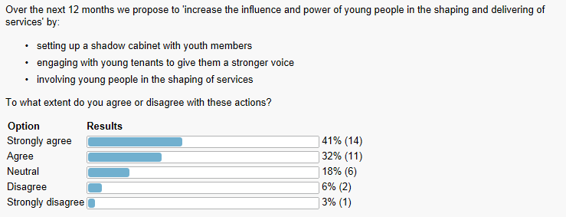

80% or more of online respondents agreed or strongly agreed with each of the underlying principles of the plan.

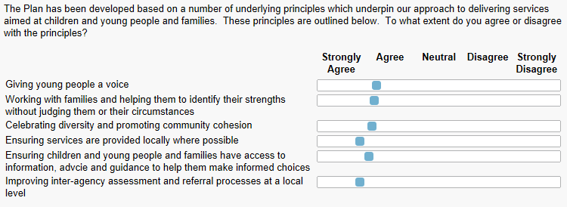

**OTHER COMMENTS**

Respondents would like to understand how this plan fits with other plans including:

* Plans at county level for children & young people
* Priorities of plans such as the Health and Wellbeing strategy, local transport plan, police etc

Comments highlighted concerns about funding and the need for progress to be measurable:

* *“All seems v sensible. I hope there is budget to implement it fully.”*
* *“I agree with the principles and aims but there is little clarity of how they will be achieved, especially in the current climate and the massive cuts being made to services.”*

Suggested additions or changes include:

* Tackling obesity through everyday walking/cycling;
* Cultural activity / participation;
* Improve environment including green space;
* Voluntary work in the community;
* Links to youth employment and apprenticeships;
* Learn “what worked” from successful young people
* Replace “skills” with “life skills”;
* Distinguish between short term residents (university students) and long term residents;
* Focus limited resources on “those in real need”;
* Working with the third sector and social enterprise.
* ‘Celebrating diversity’ and ‘community cohesion’ are not necessarily the same.

A detailed response to each comment will be made publically available.